Nightly Old Tags

* Currently till date total number of nightly tags are 30,57,976 tags in all the repositories.
* This is the Jenkins job for counting the tags
* The total count of tags which are older than 360 days are 826340

**Git clone to local**

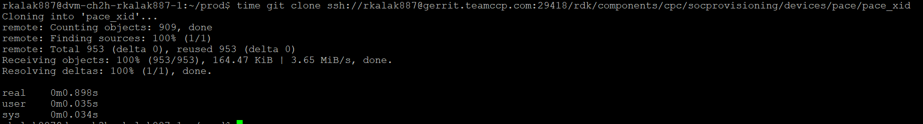

Git clone in local time taken before deleting the tags is 0.898 seconds

* time git ls-remote –tags

real 0m0.485s

* time git ls-remote --tags | grep nightly

real 0m0.415s

One of the big repos we have in git is

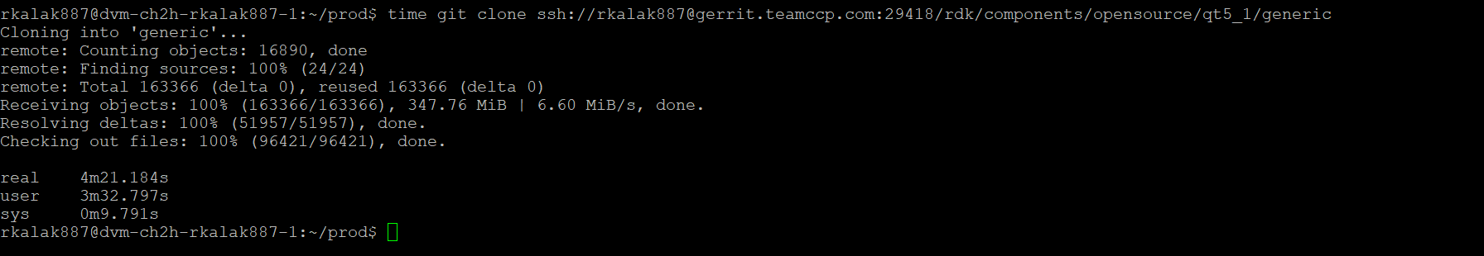

Git clone in local time taken before deleting the tags is 4 minutes and 21 seconds.

* time git ls-remote –tags

real 0m1.867s

* time git ls-remote --tags | grep nightly

real 0m1.348s

**Current Mechanism**

* The Jenkins build has 2 parts while building

1. **Repo sync** (This is done with no tags) So no tags are being pulled here.
2. **Repo init** (This pulls branches and tags while building)  
   Here it pulls all the tags from **git-repo** This process is taking 1 second

And from that specific manifest only, not all the repos. This process is taking 3 minutes (For nightly tags which is 1 min 50 seconds).

* Each Jenkins build is pulling approximately of **7000 tags** from the manifest out of which **3500 tags are nightly**. This is an approximate number.

**NOTE**: To Avoid these no tags during the repo init process also the Gerrit must be moved to a higher version which will support no tags option for repo init which will save 3 minutes of build time.

**Usage of Deleting Nightly tags**

* Gerrit cleanup of unused tags.
* Thiswill help the time to clone any repo locally.
* This will delete the older tags inside the manifest files also which may reduce approximately 50 seconds of build time)

The total count of tags which are deleted from all the repos are 836472